**Python if...else Statement**

In computer programming, the if statement is a conditional statement. It is used to execute a block of code only when a specific condition is met. For example,

Suppose we need to assign different grades to students based on their scores.

1. If a student scores above **90**, assign grade **A**
2. If a student scores above **75**, assign grade **B**
3. If a student scores above **65**, assign grade **C**

These conditional tasks can be achieved using the if statement.

**Python if Statement**

An if statement executes a block of code only when the specified condition is met.

**Syntax**

if condition:

# body of if statement

Here, **condition** is a boolean expression, such as number > 5, that evaluates to either True or False.

* If condition evaluates to True, the body of the if statement is executed.
* If condition evaluates to False, the body of the if statement will be skipped from execution.

Let's look at an example.

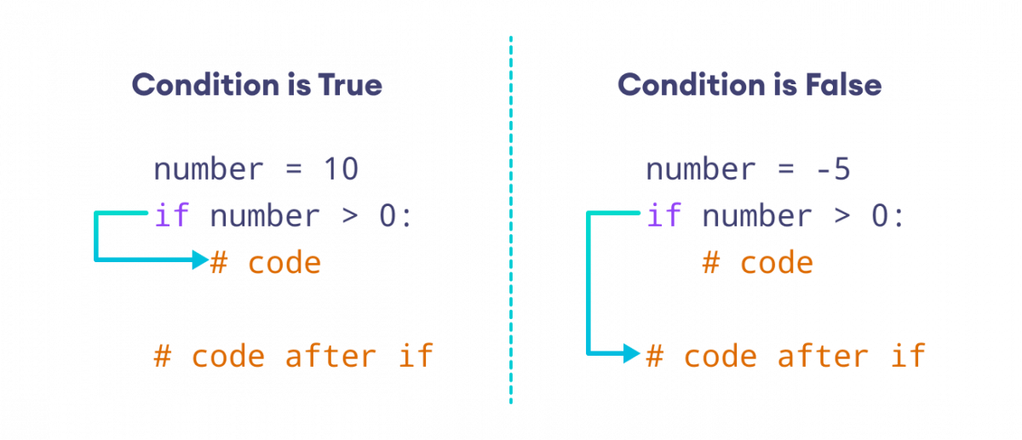Working of if Statement

**Example: Python if Statement**

number = int(input('Enter a number: '))

# check if number is greater than 0

if number > 0:

print(f'{number} is a positive number.')

print('A statement outside the if statement.')

[Run Code](https://www.programiz.com/python-programming/online-compiler)

**Sample Output 1**

Enter a number: 10

10 is a positive number.

A statement outside the if statement.

If user enters **10**, the condition number > 0 evaluates to True. Therefore, the body of if is executed.

**Sample Output 2**

Enter a number: -2

A statement outside the if statement.

If user enters **-2**, the condition number > 0 evaluates to False. Therefore, the body of if is skipped from execution.

**Indentation in Python**

Python uses indentation to define a block of code, such as the body of an if statement. For example,

x = 1

total = 0

# start of the if statement

if x != 0:

total += x

print(total)

# end of the if statement

print("This is always executed.")

[Run Code](https://www.programiz.com/python-programming/online-compiler)

Here, the body of if has two statements. We know this because two statements (immediately after if) start with indentation.

We usually use four spaces for indentation in Python, although any number of spaces works as long as we are consistent.

You will get an error if you write the above code like this:

# Error code

x = 1

total = 0

if x != 0:

total += x

print(total)

[Run Code](https://www.programiz.com/python-programming/online-compiler)

Here, we haven't used indentation after the if statement. In this case, Python thinks our if statement is empty, which results in an error.

**Python if...else Statement**

An if statement can have an optional else clause. The else statement executes if the condition in the if statement evaluates to False.

**Syntax**

if condition:

# body of if statement

else:

# body of else statement

Here, if the condition inside the if statement evaluates to

* **True** - the body of if executes, and the body of else is skipped.
* **False** - the body of else executes, and the body of if is skipped

Let's look at an example.

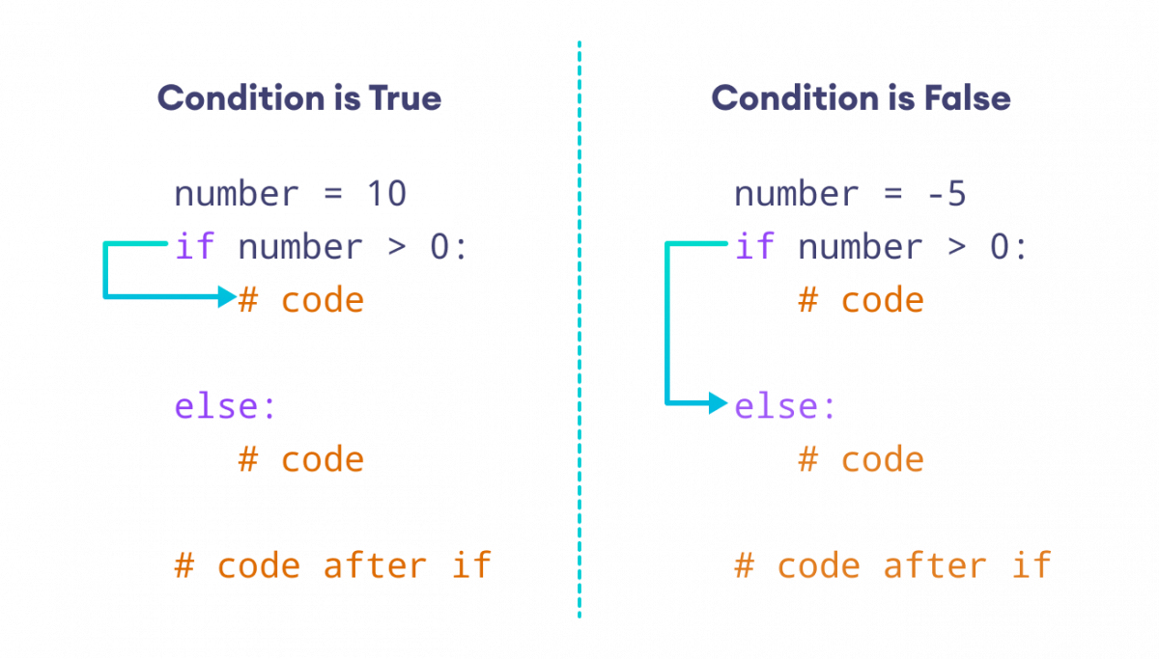Working of if…else Statement

**Example: Python if…else Statement**

number = int(input('Enter a number: '))

if number > 0:

print('Positive number')

else:

print('Not a positive number')

print('This statement always executes')

[Run Code](https://www.programiz.com/python-programming/online-compiler)

**Sample Output 1**

Enter a number: 10

Positive number

This statement always executes

If user enters **10**, the condition number > 0 evalutes to True. Therefore, the body of if is executed and the body of else is skipped.

**Sample Output 2**

Enter a number: 0

Not a positive number

This statement always executes

If user enters **0**, the condition number > 0 evalutes to False. Therefore, the body of if is skipped and the body of else is executed.

**Python if…elif…else Statement**

The if...else statement is used to execute a block of code among two alternatives.

However, if we need to make a choice between more than two alternatives, we use the if...elif...else statement.

**Syntax**

if condition1:

# code block 1

elif condition2:

# code block 2

else:

# code block 3

Let's look at an example.

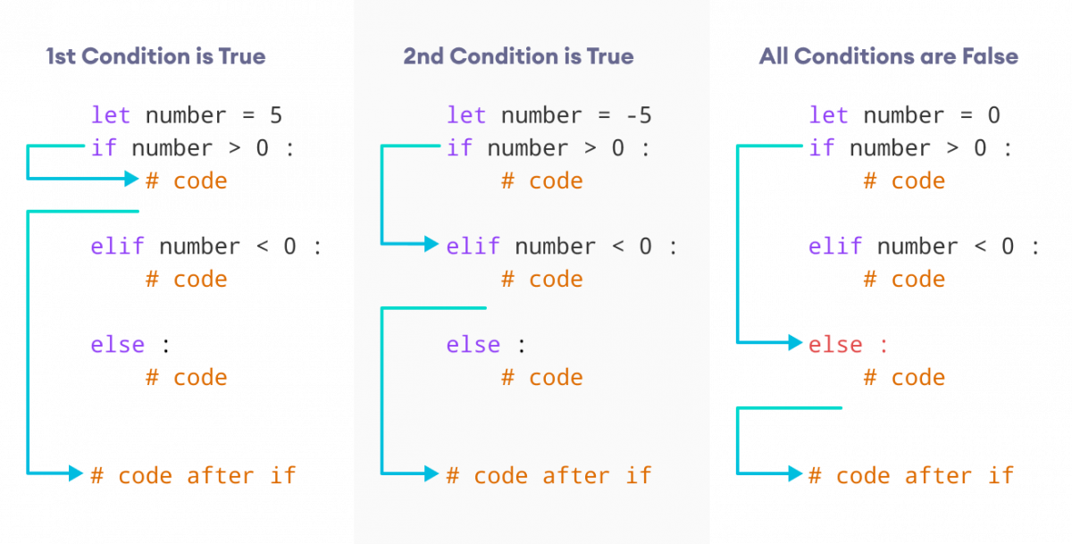Working of if…elif…else Statement

**Example: Python if…elif…else Statement**

number = -5

if number > 0:

print('Positive number')

elif number < 0:

print('Negative number')

else:

print('Zero')

print('This statement is always executed')

[Run Code](https://www.programiz.com/python-programming/online-compiler)

**Output**

Negative number

This statement is always executed

Here, the first condition, number > 0, evaluates to False. In this scenario, the second condition is checked.

The second condition, number < 0, evaluates to True. Therefore, the statements inside the elif block is executed.

In the above program, it is important to note that regardless the value of number variable, only one block of code will be executed.

**Python Nested if Statements**

It is possible to include an if statement inside another if statement. For example,

number = 5

# outer if statement

if number >= 0:

# inner if statement

if number == 0:

print('Number is 0')

# inner else statement

else:

print('Number is positive')

# outer else statement

else:

print('Number is negative')

[Run Code](https://www.programiz.com/python-programming/online-compiler)

**Output**

Number is positive

Here's how this program works.

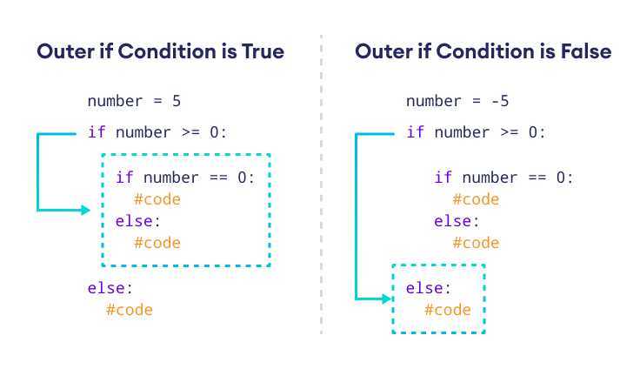Working of Nested if Statement